

Instruction Manual
v1.1

Where are the Logo and Flag changer are located?

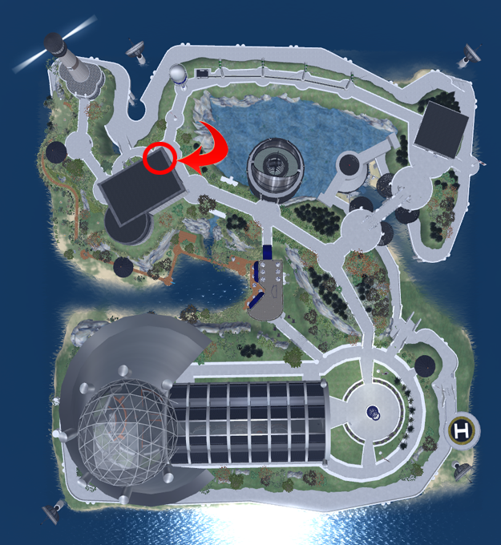
The objects that contain the scripts and notecards for the
tutorials below are located in the 2nd floor lobby of the
build highlighted by the red circle and arrow above.

Once you have located these items continue to the next page.

How to modify logo and flag changers

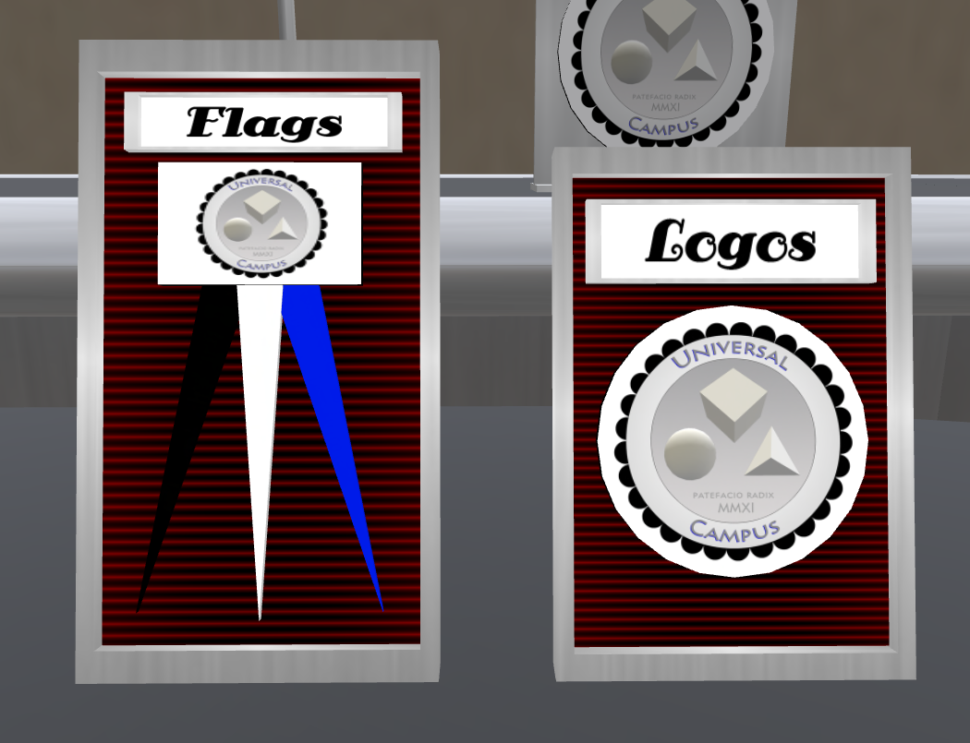
The flag and logo changers allow you to easily change all the logos and flags in the region as you need just by adding the uuid of your texture to the notecard in the button of the items shown below.

First you must start by editing the button as highlighted in green below:


Step 2:

next you need to open the config notecard in the contents tab of this button

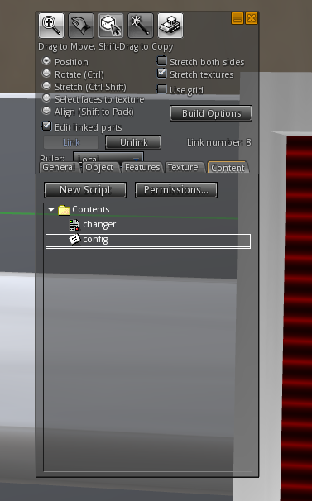
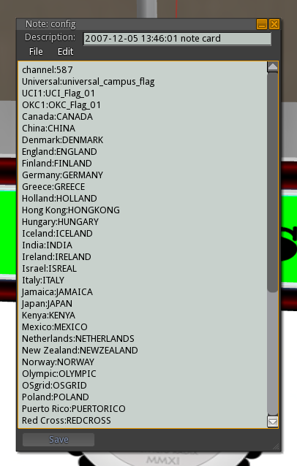

you now need to upload your logo or flag then proceed to next step

Step 3:

After you have uploaded your logo or flag texture you will need to copy its uuid from your inventory by right clicking on the texture and copy uuid.

as shown below:
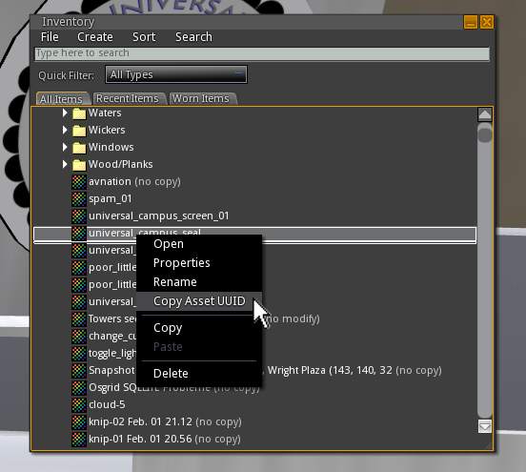
Next step is to add your texture name and uuid to the config notecard, the name you select is what will be shown on the selection menu of the changer.

Step 4:

Add your name and uuid as shown below:

ie: My Logo 1:43bbe565-8066-435f-944c-18a2b55fcb25
(name:uuid)
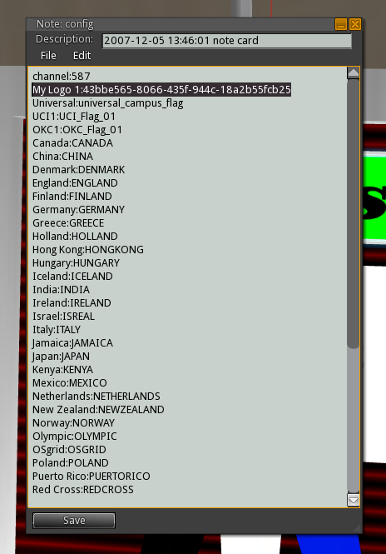

once you have added your logo(s) hit save and your done.

Step 5:

Now you can hit the Logo or Flag button to select your flag from the menu


this will bring up the following interaction menu

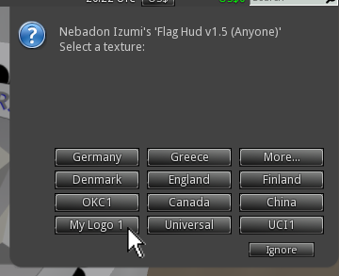
That is it, once you select “My Logo 1”
all the logos in the entire sim will change.
You can add as many logos or flags as you like.

Making your own flag for the changer


above is a sample flag texture.
(example is included in root prim of the changer)

As you can see the flag is the left 50% of the image, and the 3 color strip to the right 50% of the texture is the tassles for the flag. You can see the final example in the image below:



